Working With Links In HTML 5

Links are the defining feature of the web because they allow you to move from one web page to another enabling the very idea of browsing or surfing.

You will commonly come across the following types of links:

* Links from one website to another
* Links from one page to another on the same website
* Links from one part of a web page to another part of the same page
* Links that open in a new browser window
* Links that start up your email program and address a new email to someone

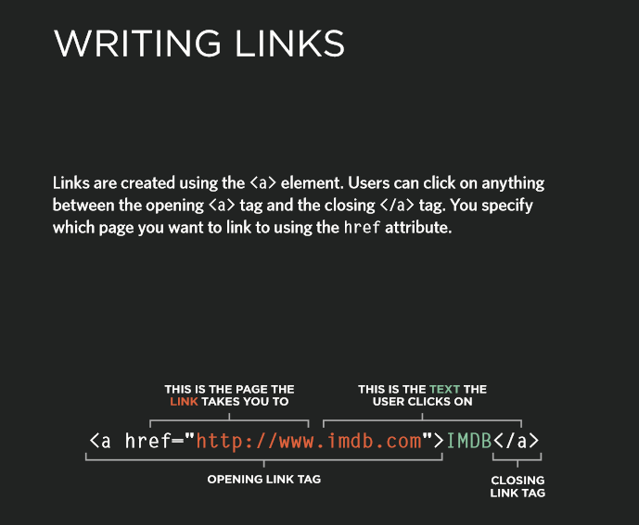

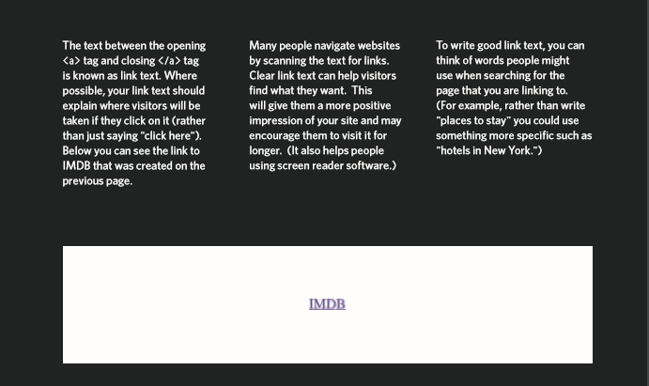

Linking to other Pages on the same site:

When you are linking to other pages within the same site, you do not need to specify the domain name in the URL. You can use a short hand known as a relative URL.

If all the pages of the site are in the same folder, then the value of the href attribute is just the name of the file.

If you have different pages of a site in different folders, then you can use a slightly more complex syntax to indicate where the page is in relation to the current page.